PRACTICAL ACTIVITY 4

VIRTUOUS FANNY

[virtuous.fanny@womentechsters.org](mailto:virtuous.fanny@womentechsters.org)

1. Code for “strong password”

See image below:

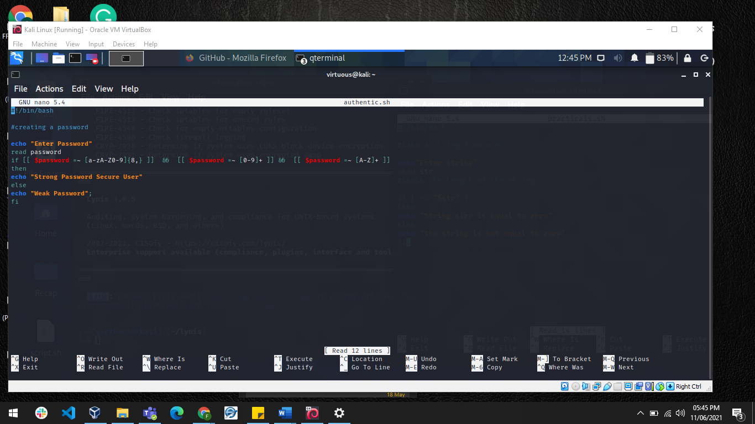

2. Checking if the password meets the following requirement:

* Length – minimum of 8 characters.
* Contain both alphabet and number.
* Include both the small and capital case letters.

See image below:

